Description

Task Summary
Validate the logistics source data to ensure completeness, consistency, and integrity before transformation.
Sub-tasks
- Import logistics dataset into MySQL
- Validate row counts
- Verify referential integrity
- Analyze source data quality

Step 1 — Create the schema

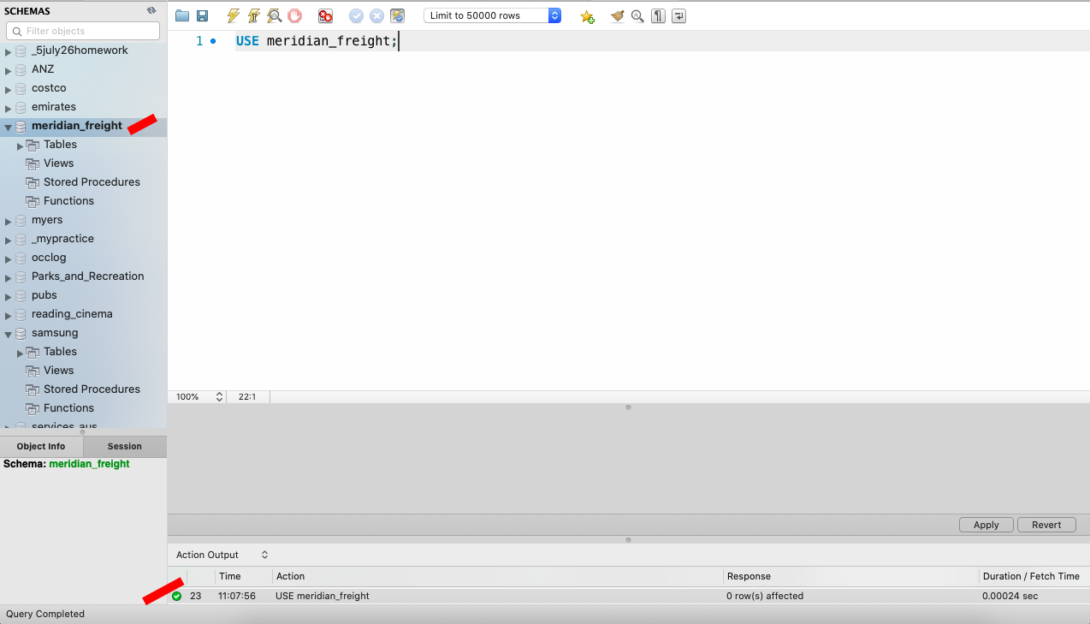

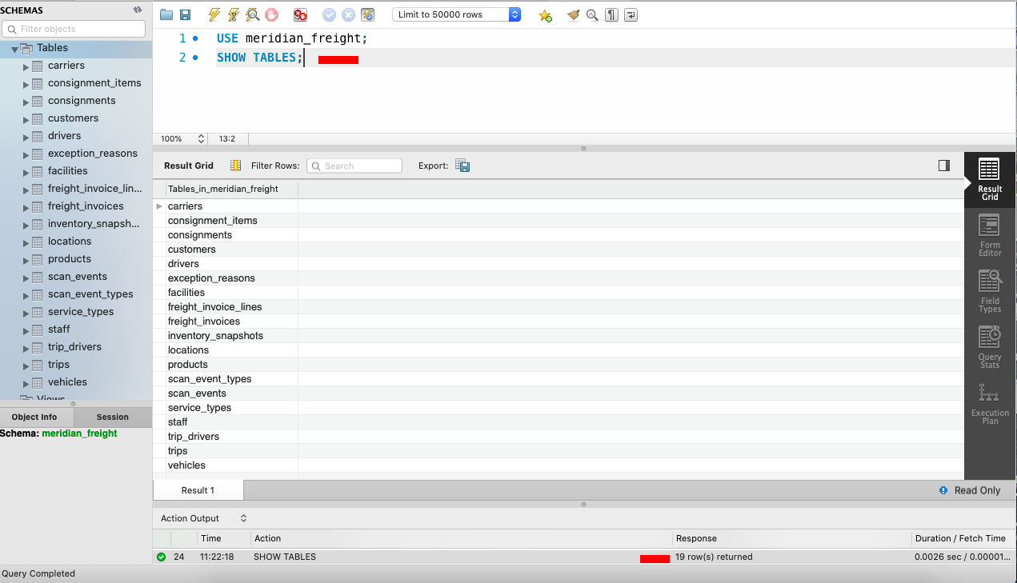

Step 2 — Load the CSV files

Option C — Python loader (most robust; no server configuration at all) was used

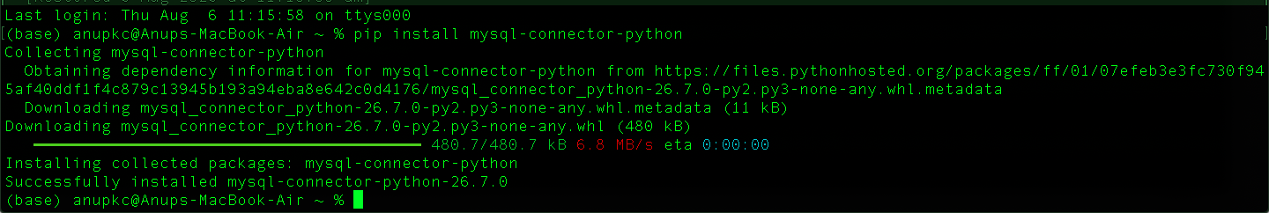

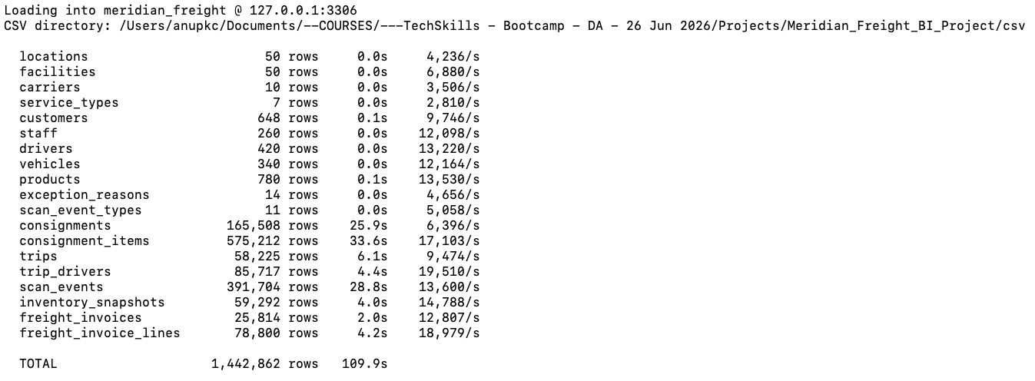

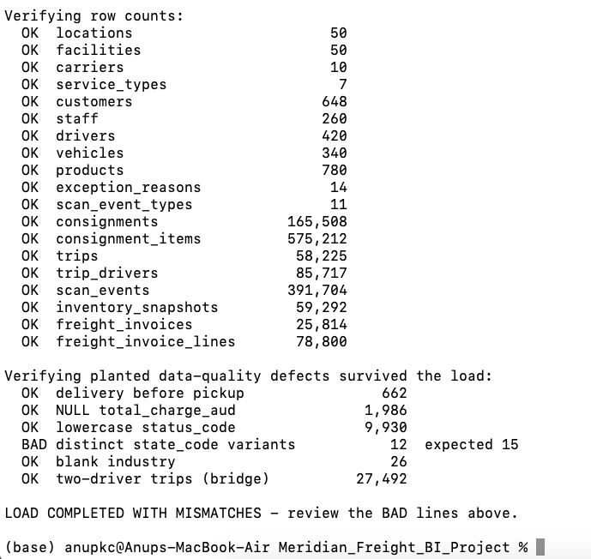

Step 3 — Verify the load

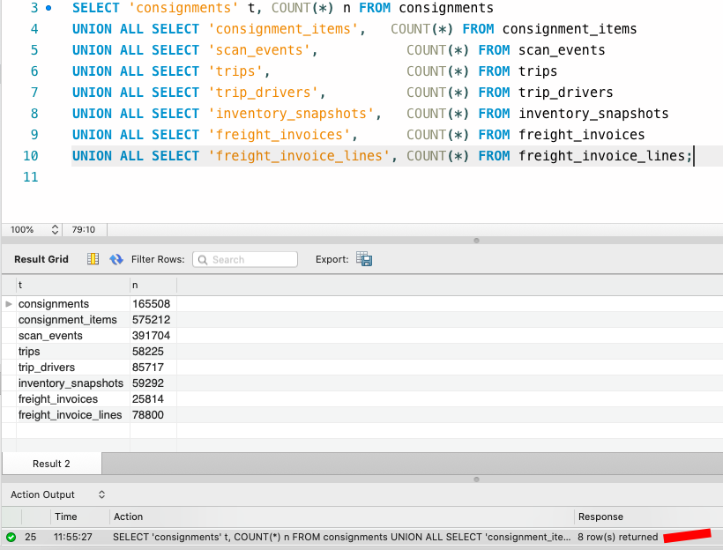

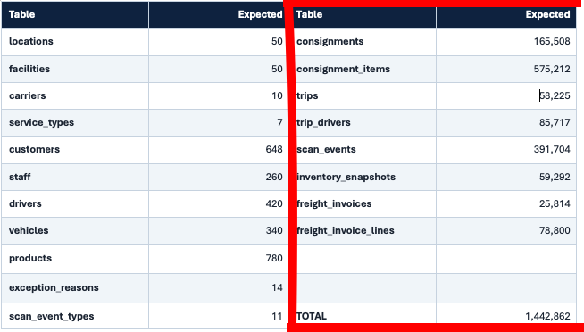

Step 4 — Verify referential integrity

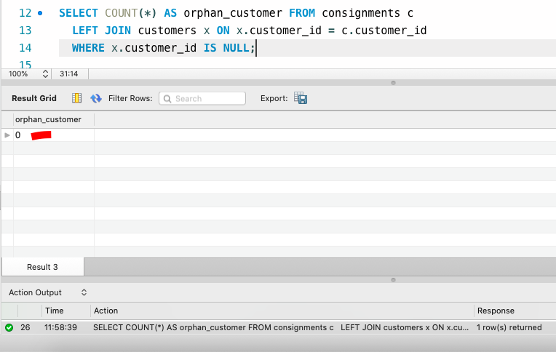

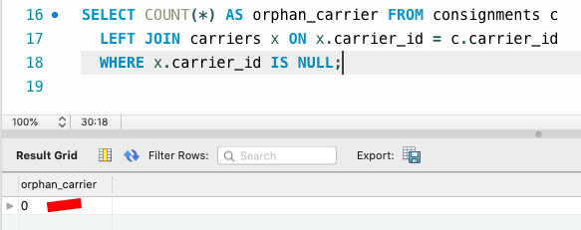

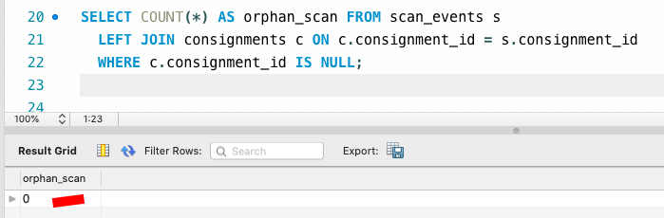

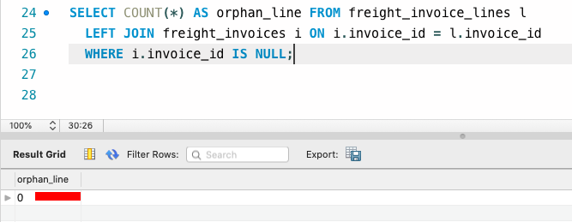

Step 5 — Confirm the defects survived
Here state_variants was expected 15 but reporting 12.

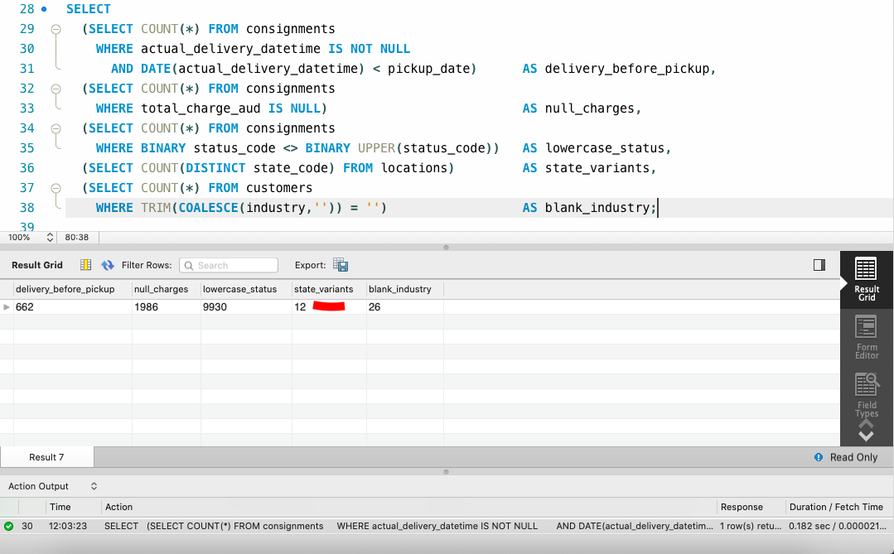

Part 6

6.1 Cleaning the geography entity

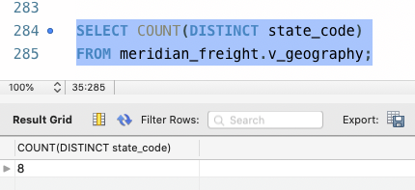

6.2 Deduplicating customers

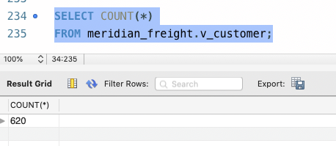

-- =====================================================================
-- SECTION 4 : VALIDATION QUERIES
-- Run these AFTER creating the views to prove the cleaning worked.
-- =====================================================================

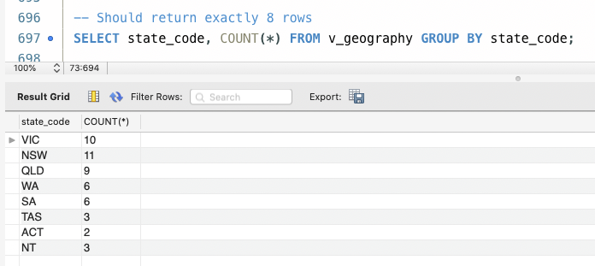

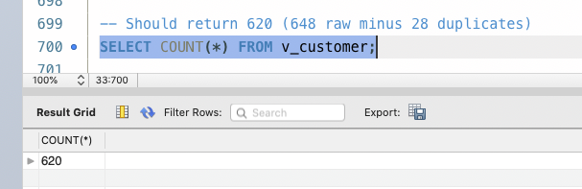

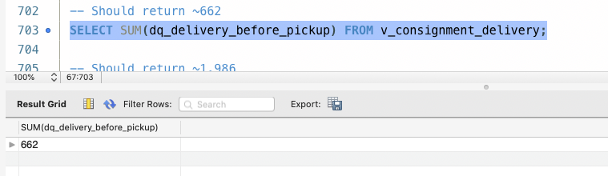

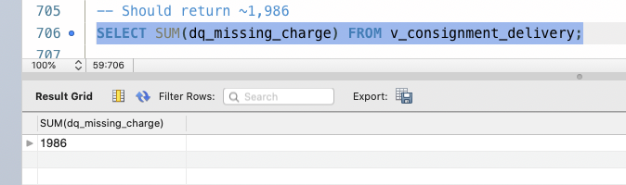

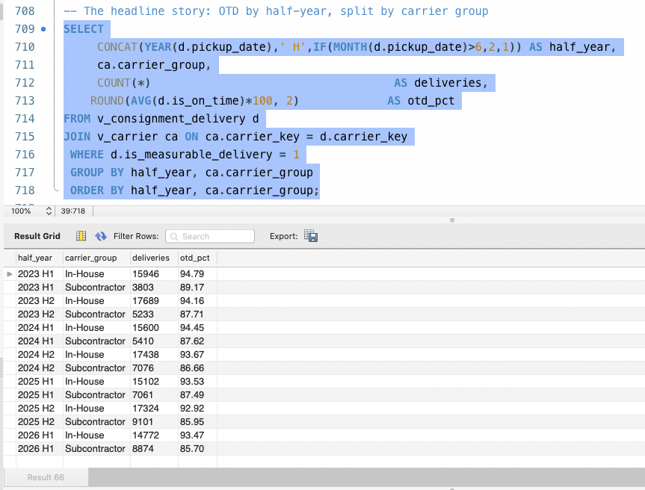

6.5 The bridge – resolving many-to-many
